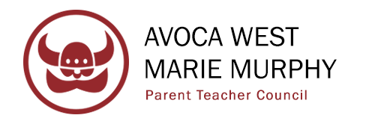
Agenda
November 8th, 2023, Marie Murphy School
Parent Teacher Council Open Meeting 7:00 pm

PTC President Ross Friedman to open meeting.
I. | Welcome
II. | District Update
IV. | Upcoming Events/Activities  - Intercultural Night – Saturday 11/11
V. | Budget & Finances  - Discuss proposed budget and modify if necessary  - Vote on Budget
V. | Updates  - Membership  - Communications  - Volunteers  - Fundraising  - Innovation Grants  - AW VP  - MM VP
VI. | Initiatives  - Green Committee, CommunIDee, Different Learners
VIII. | New Business & Open Questions  December 13th – Closed  January 17th – Open  February 15th – Closed (THURSDAY)  March 13th – Closed  April 10th – Closed  May 8th – Open
IX. | Meeting Adjourned

